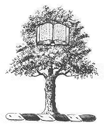
Parkes Institute for the Study of Jewish/non-Jewish Relations, University of Southampton

1st International Workshop on Jewish Heritage
Heritage and Its Communities

Highfield House Hotel, Southampton and University of Southampton

11-13 July 2016

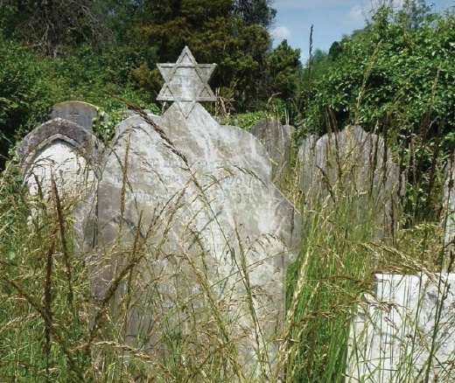 | 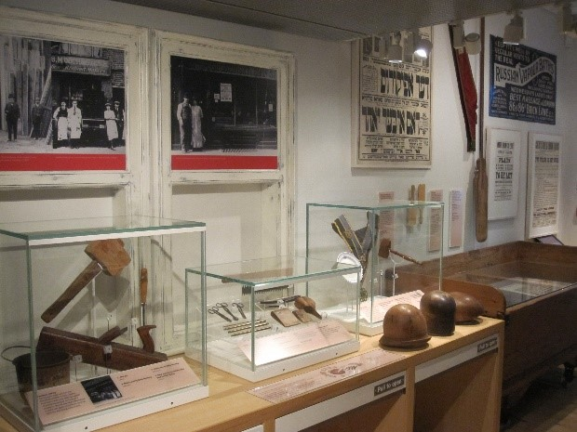

Programme
Conference venue: Highfield Hotel, 119 Highfield Lane, Southampton, SO17 1AQ

Sunday, 10 July 2016
18.30 Welcome and drinks for speakers and participants at Highfield House
20.00 Dinner at own expense in Portswood

Monday, 11 July 2016
09.30 Registration
Setting up of poster display and signing up for 10 min session with Sally Berkovic, Director of Rothschild Foundation Europe on Tuesday
11.00 Welcome by Professor Joachim Schloer, Director of the Parkes Institute for the Study of Jewish/non-Jewish Relations, University of Southampton, and Dr Kathrin Pieren and Professor Tony Kushner, organisers of the programme
11.15 Jakub Nowakowski, Executive Director, Galicia Jewish Museum
‘Jewish museums in post-Jewish spaces’ (Lecture)
12.45 Lunch
13.45 Cilly Kugelmann, Program Director and Deputy Director, Jewish Museum Berlin
‘Jewish communities and their relation to Jewish museums’ (Workshop)
15.45 Coffee break
16.15 Project showcase

Alicja Mroczkowska, Emanuel Ringelblum, Jewish Historical Institute in Warsaw ‘The role of the Emanuel Ringelblum Jewish Historical Institute in the preservation and documentation of Jewish heritage in Poland’
Tudor Drambarean, Cristiania Fica, Alba Julia Municipality, ‘Projects to protect Jewish heritage at the Alba Iulia municipality in Romania’
Dr Katalin Deme, University of Aarhus, ‘The Jewish holdings of the Fredericia Municipal Museum in Southern Denmark’
Abigail Morris, Chief Executive Officer, Jewish Museum London, ‘The Jewish Museum London: Forward Vision’
Marcus Roberts, Director JTrails, ‘Communities and contested heritage’
Chair: Dr James Jordan, Parkes Institute and University of Southampton
18.00 Trip to Southampton on the search of the hidden traces of Jewish history in the built heritage led by Professor Tony Kushner
19.45 Conference dinner in Southampton town centre

Tuesday, 12 July 2016
8.30 Registration
9.00 Trip to Winchester on the search of the hidden traces of Jewish history led by Professor Patricia Skinner, Department of History, University of Winchester
11.30 Coffee break
12.00 Peter Aiers, Director North and South East and Head of Regeneration, The Churches Conservation Trust
‘Working successfully with communities to turn sacred into secular spaces’ (Workshop)
13.30 Lunch
An opportunity to discuss your heritage project with Sally Berkovic, CEO, Rothschild Foundation (Hanadiv) Europe. (Sign up on arrival to the workshop for 1:1 10 minute slots).
14.30 Ruth Ellen Gruber, Writer and Researcher, Co-ordinator Jewish Heritage Europe
‘Jewish heritage in the digital age: impact on communities’ (Workshop)
16.00 Coffee break
16.30 Dr Alla Sokolova, Curator, State Museum of the History of Religions, St Petersburg and Lecturer at the Center ‘Petersburg Judaica’ at the European University of St Petersburg
‘Collecting and representing tangible and intangible heritage: source communities and authenticity’ (Lecture)
Chair: Professor Tony Kushner, Parkes Institute and University of Southampton
17.45 Drinks and screening of the film ‘A town called Brzostek’ (2014) by Simon Target, followed by a discussion
19.15 Dinner at participants’ own expense

Wednesday, 13 July 2016
9.00 Registration
9.30 Dr Karen Robson, Head of Archives (including Anglo-Jewish Archives), University of Southampton
‘Archives and audiences: engaging with our users’ (Workshop)
11.00 Coffee break
11.30 Professor Joachim Schloer, Director of the Parkes Institute for the Study of Jewish/non-Jewish Relations, University of Southampton
‘Jewish migration and the archive’ (Lecture)
13.00 Lunch
14.00 ‘(How) can heritage strengthen and empower communities?’ (Debate)
Debra Brunner, Director, The Together Plan (Brest Headstone Memorial Project)
Peter Aiers, Director North and South East and Head of Regeneration, The Churches Conservation Trust
Edward Dickenson, Learning Officer, Ben Uri Gallery, London
Chair: Dr Kathrin Pieren, Petersfield Museum and University of Southampton
15.30 Feedback session and discussion of next workshop theme
16.00 End of conference

